**Data Analytics**

**Assignment-3**

# Name: Batchu Ramya

# Reg. No: 21BCE9106

# College: VITAP

8 visualizations using tableau:

## 1. Bubble Chart

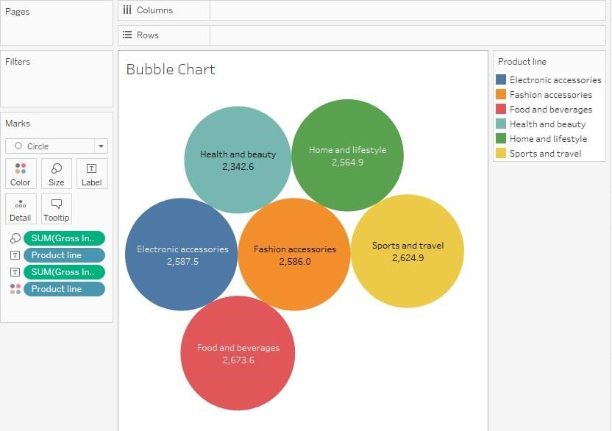

## 2. Bar Chart

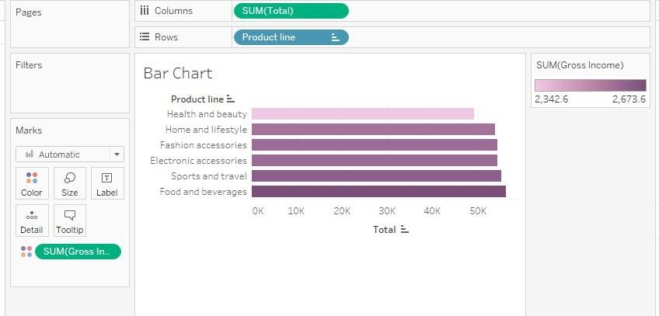

## 3. Tree Map

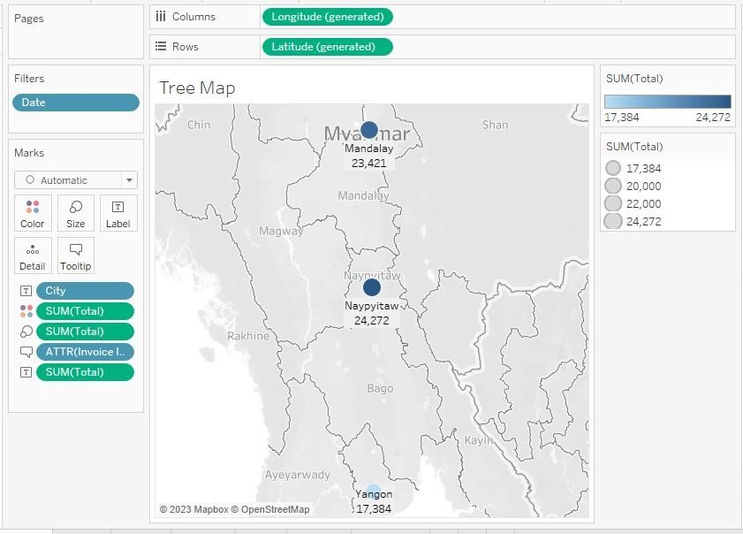

## 4. Pie chart

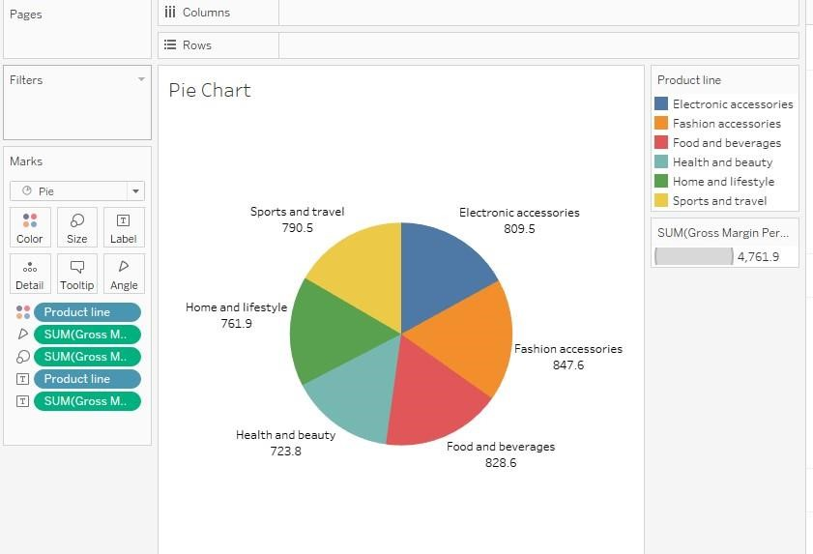

## 5. Heat Map

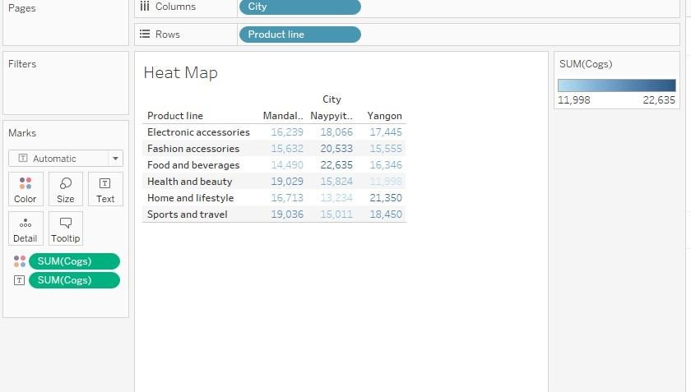

## 6. Line Chart

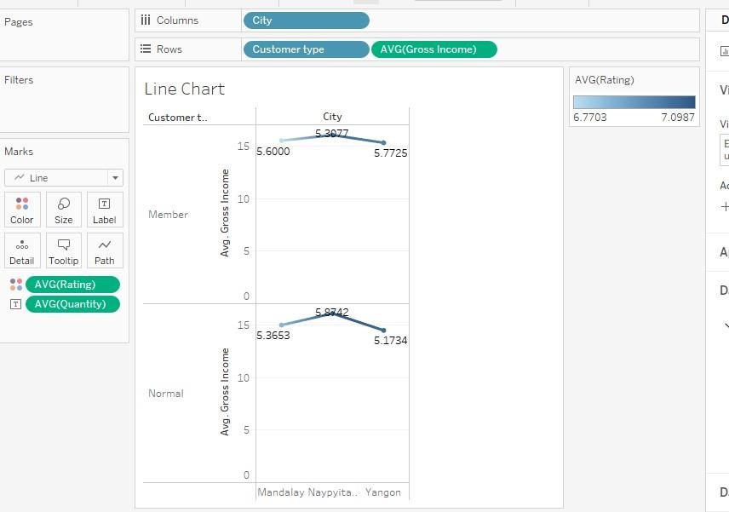

## 7. Box plot

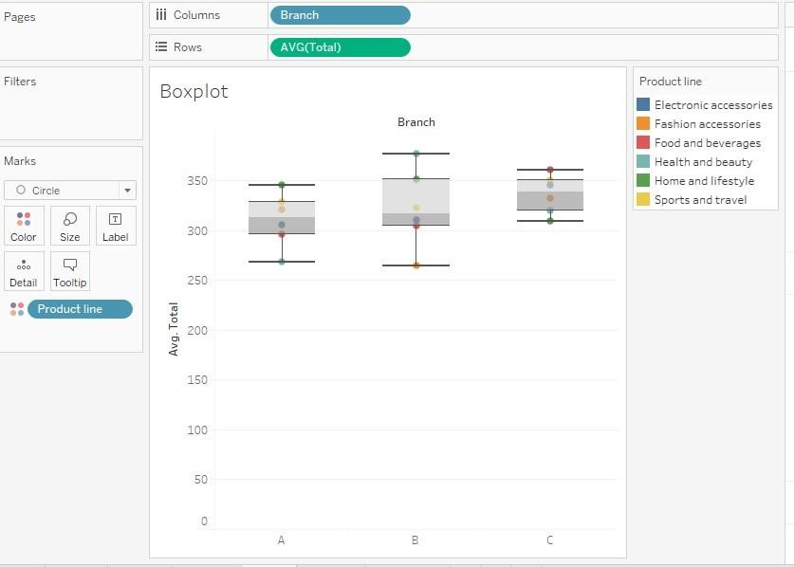

## 8. Histogram

